Sir Isaac Newton: Biography
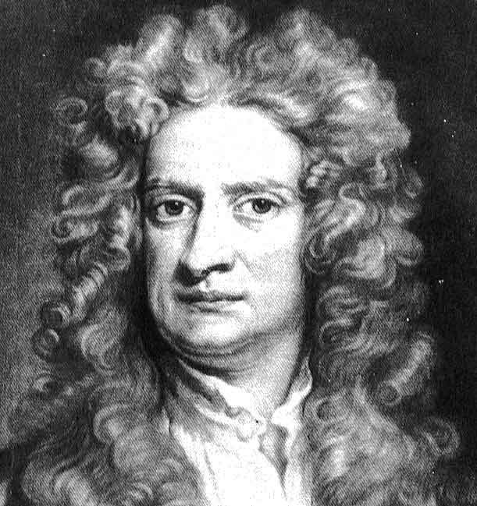
Sir Isaac Newton was born in the county of Lincolnshire, England in 1643.
His father died just months before he was born, and when he was three years old, his mother left him in the care of his grandmother.
Isaac was always a top student, and went off to the University of Cambridge at age 19. While at Cambridge, Newton was influenced by the writings of famous scientists like Galileo, Nicholas Copernicus, and Johannes Kepler.
Newton would go on to discover other important math theories such as Newton’s Identities, and Newton’s Method, and Newton's Laws of Motion.
In 1670, Newton moved to study optics and developed theories relating to the composition of white light and the spectrum of colors. In one of his famous experiments, he refracted white light with a prism, resolving it into its constituent colors: red, orange, yellow, green, blue, and violet. As a result of his experiments, he developed Newton’s Theory of Color.
Newton then created the world’s first color wheel, which arranged different colors around the circumference of a circle. He is the first scientist to explain the formation of a rainbow – from water droplets in the atmosphere.
In 1679, Newton continued his work on gravitation and its effects on the planets. According to Newton, gravity is the reason that objects fall to the ground when dropped. We now know gravity is the reason why planets orbit the sun, moons orbit planets, and why ocean tides exist.
In 1687, he published Philosophiae Naturalis Principia Mathematica. In this landmark work, Newton explained his three laws of motion, which included his theory on gravity. Below are Newton’s three laws of motion:
Newton’s First Law (Law of Inertia) states that an object at rest tends to stay at rest and that an object in uniform motion tends to stay in uniform motion unless acted upon by an external force.
Newton’s Second Law states that an applied force on an object equals the time rate of change of its momentum. (F=ma)
Newton’s Third Law states that for every action there is an equal and opposite reaction.
Following the publication of his work, Newton became instantly famous throughout Europe. In the later years of his life he wrote several articles on interpretation of the bible. He was also appointed a member of the British Parliament and spent many years reforming the Royal Mint (coin making agency of Parliament). He died on March 20, 1727.
Name: ______________________________________________ Group: ___________________ Date: ______________________
Sir Isaac Newton Biography
Directions: Read the short biography about Sir Isaac Newton on the back of this page. Underline the important facts while you read. When you are done, answer the questions on this page. Be sure to use complete sentences when possible, and show all of your work here.
- Fill in the timeline of Newton's Life here

- Why do you think we are learning about Newton now, after a unit on motion?
______________________________________________________________________________________
______________________________________________________________________________________

- What do you think is the most important thing Newton has done in his life?
______________________________________________________________________________________
______________________________________________________________________________________

- Use the information in the article and think about Newton being alive today -
What would his twitter name be? *be creative* @_____________________________

- Name three people Newton would "follow" on twitter
  - ____________________ b. _____________________ c. ____________________

- What would be a picture that Isaac Newton would upload onto Instagram?
Sketch it here and tell me what he would 'hashtag' the drawing.

- Why did you choose that image and that hashtag?
___________________________________________________________________________
___________________________________________________________________________
___________________________________________________________________________ # _________________________
___________________________________________________________________________

